

***PROJECT ON***

***120 Years of Olympic History Analysis***

***Course Code : CSE-317***

***Course Title : Software Project V***

***Submitted To :***

***Fariha Jahan***

***Lecturer, Department of CSE***

***DAFFODIL INTERNATIONAL UNIVERSITY***

***Submitted by :***

***Sabbir Ahmed , Id : 191-15-12867***

***Md Sahajada Hasib , Id : 191-15-12812***

***Ahsan Riad , Id : 191-15-12135***

***Tanni Rani Saha , Id : 191-15-12475***

***Ashraful Islam , Id : 191-15-12515***

***Section:- L***

**Tittle**

Data analysis including graphical representation on Athletes and Medal Results from Athens 1896 to Rio 2016 Olympic on Microsoft Power BI.

**Abstract**

The main motive of doing this project is to graphically describe how the Olympics have evolve over time, including the diversity of participation, performance of the athletes and different sports and events.

**Introduction**

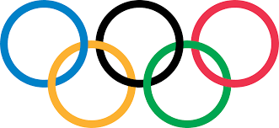

The Olympics are about diversity and unity. Over the time Olympics have become bigger. The modern Olympic Games have been important for the development of competitive sport throughout the last century. The 4‐year period of an Olympiad is celebrated every second year with Summer and Winter Games, respectively.

The success of the Olympic Games and any major sporting event is dependent upon the performances of its athletes. There are different sport and events categories in Olympic like Basketball, Artistic Gymnastics, Artistic Swimming, Badminton.

Sports provide athletes with a unique quality, where they are both the consumer and producer of an event. The success of the Olympic Games is dependent upon the performances of its athletes. To have a great result, the conditions must be optimal. From the athletes’ village to competition venues, a positive experience is essential to ensure a great performance.

**Methodology**

This data set is the result of an incredible amount of research by a group of Olympic history enthusiast. Which contains information about individual athlete competing to an individual Olympic event. There are several special attributes to specify each athlete. For example : ID - A Unique number for each athlete, The ID column can be used to uniquely identify athletes, since some athletes have the same name. The dataset also contains information about the events, participated teams, Medals etc.

We upload it on server using MySQL and then get the data using Microsoft Power BI for further graphical representation.

**Result on Discussion**

FroIm the datasets,In those graph we show that the…

By filtering out event on the basis of country it seems that total one third of the events are conducted in USA, Germany, France and UK.

By filtering out event on the basis of city it found out that the highest 22426 events conducted in London and only 2639 events conducted in Calgary.

By filtering out event on the basis of year it seems that the highest total event conducted in year 1998 and the lowest total event conducted in 1896.

By filtering out participation of teams on the basis of year it seems that the highest total 29 teams participated in year 2008.

*1.The count of medel by age, this graph we show that here the age limit is (14 to 23), and highest count of medel number is 21.9k whom age limit is 23. And lowest count of model*

*number is 0.8k whom age limit is 14.*

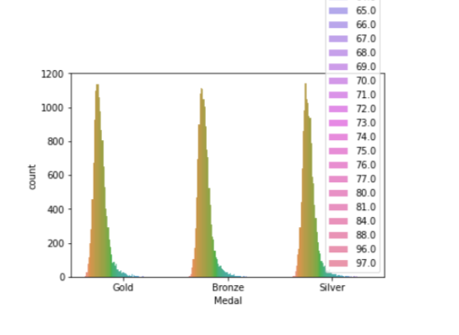

*2. Count of Athleticss by gender, this graph we show that male & female gender people participant . Highest Athleticss number 196.5k whom 72.51% is male. And lowest Athleticss number 74.52k whom 27.49% is female.*

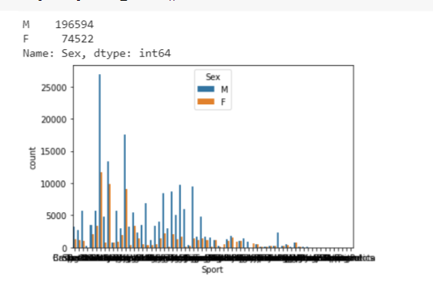

*Count of medel by gender, this graph we show that male & female gender people participant . Highest medel number 196.59k whom 72.51% is male. And lowest Athleticss number 74.52k whom 27.49% is female.*

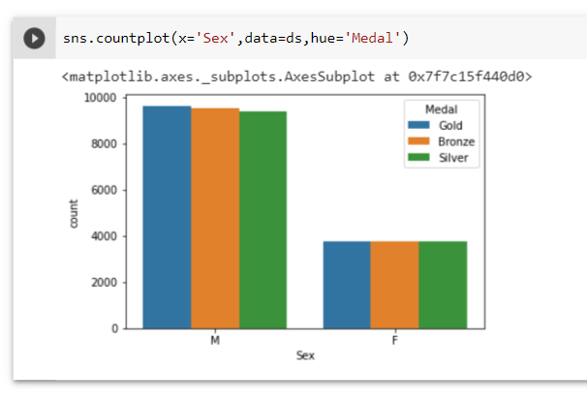

*3.Count of medel by country in this graph for whole country medel number is (0k to 18.85k)*

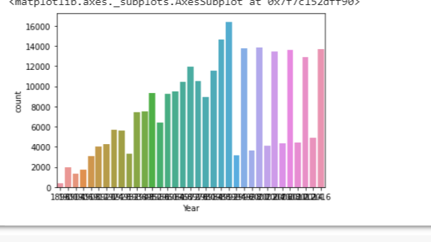

*4. Count of event by year in this graph , Event number of 0k to 20k in 1880-2020.*

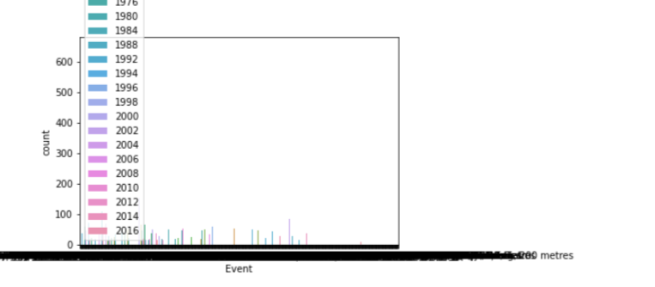

*5. Count of total Sport and count of total sport by team.*

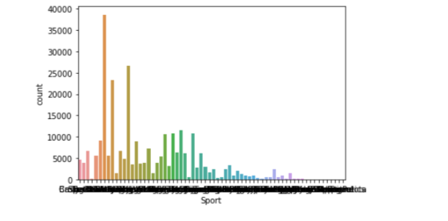

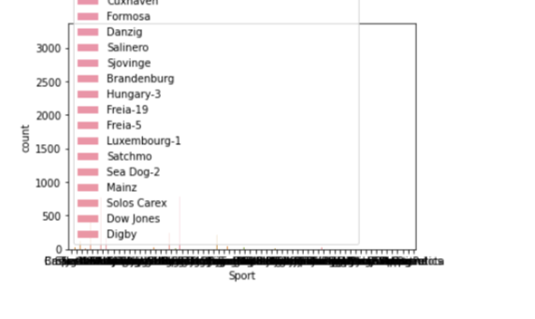

***6. Count of sport by medal.***

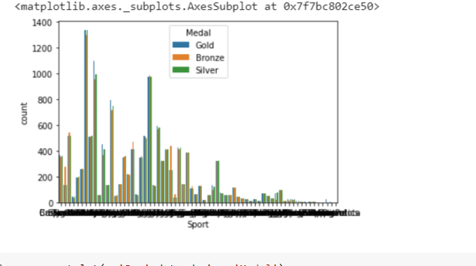

***7. Count of medal by gende***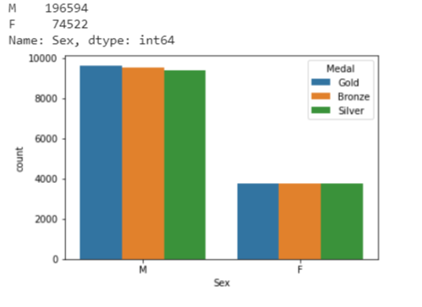

*8. Count of event by Country , Count of City by Medal.*

**

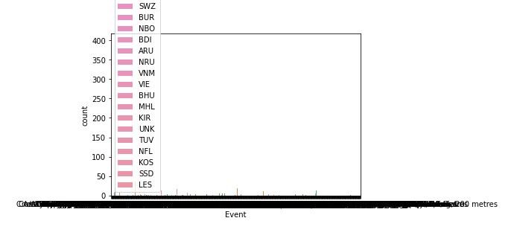

*The purpose of this review was to examine the state of Olympic media research with the intent of highlighting trends in the established literature base, while simultaneously uncovering areas for development. The review yielded insights into the types of research being produced from theoretical, methodological, and contextual perspectives. Based on the results, this section provides further discussion* of the following key areas identified for continued development in the Olympic media research space: embracing and grounding research in theory, diversification in research context, and expanding upon the definition of the Olympic Games within the greater Olympic Movement.

**Conclusion**

Our goal to describe this huge data set in a way which will coer all the important aspects of Olympic. This project will help Olympic enthusiast to describe how Olympics have evolve over time, including questions about the participation and performance of women, different nations, and different sports and events.